1. 
2. **Agenda**:
   1. We will design a sample RESTful API for our simple Social Media App.
3. 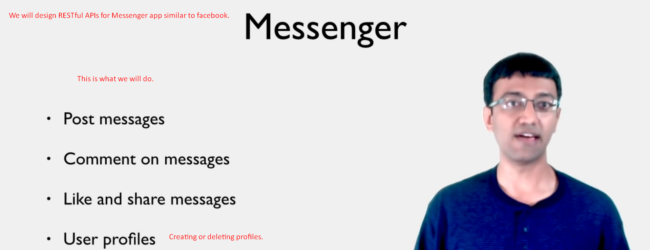
4. 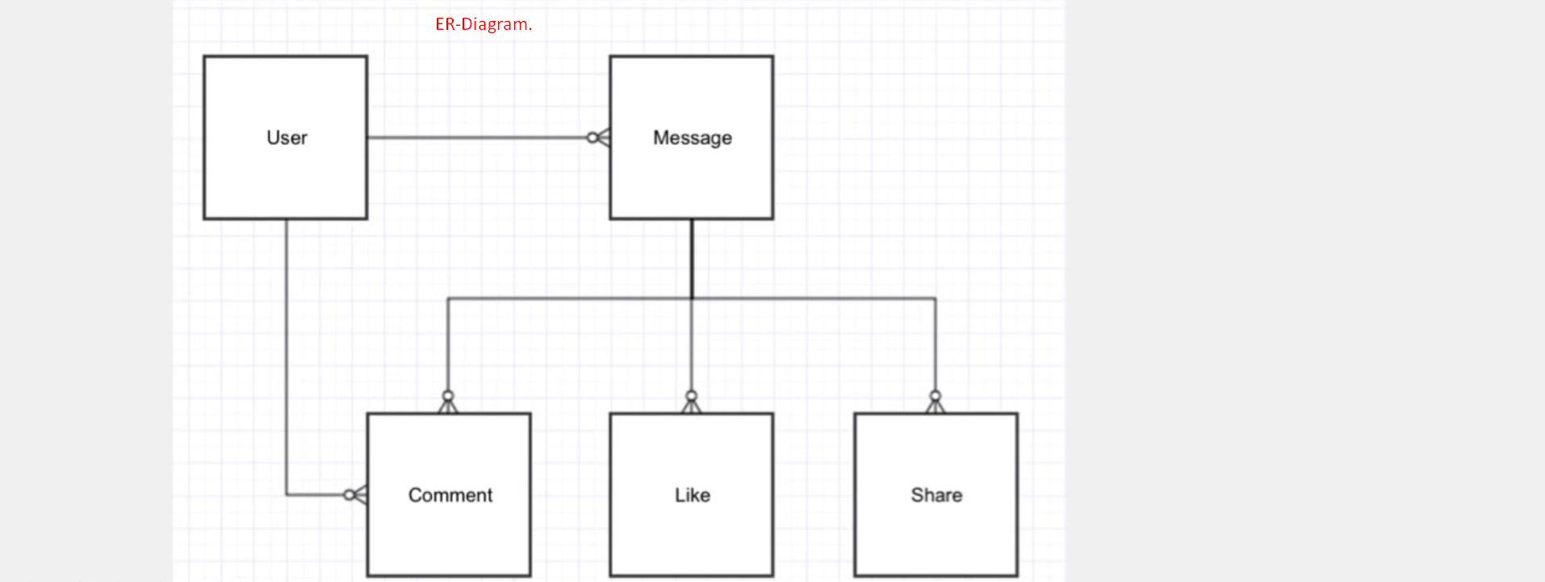  
   Basic entities interrelated with each other.  
   Message table contains all the messages along with who posted them.
5. Let’s discuss what URIs you design for this app.
6. **Web App URIs**:
   1.   
      These URIs are for web app as web app’s clients don’t need to remember the URIs (except for the home page) so you too don’t care what URIs you design.
   2. However, to write REST APIs, the consumers have to be aware of URIs as the consumers of your REST APIs are developers who have to write code to make calls to these URIs.
   3. 3:32